Neurograph User Manual

© Jiashu Wu 2018

User Manual for Neurograph Version 1.0

2018.06

Table of Contents

[App Icon and Welcome Page 6](#_Toc514486907)

[Home Page 6](#_Toc514486908)

[Choose Your Preferred Language 7](#_Toc514486909)

[Choose Font Size 7](#_Toc514486910)

[Choose your preferred colour theme 8](#_Toc514486911)

[View App information 8](#_Toc514486912)

[View Device Information 9](#_Toc514486913)

[View copyright information 9](#_Toc514486914)

[Clean App Cache 10](#_Toc514486915)

[View information about the app 10](#_Toc514486916)

[View Tutorials 11](#_Toc514486917)

[Click Let’s Start to log in 12](#_Toc514486918)

[Account centre 12](#_Toc514486919)

[Registration Page 13](#_Toc514486920)

[Registration Code 14](#_Toc514486921)

[Information Collection 15](#_Toc514486922)

[Test Selection 18](#_Toc514486923)

[Parallel Line Practice 19](#_Toc514486924)

[Choose painter width before starting 20](#_Toc514486925)

[Finish & Clear 21](#_Toc514486926)

[Calculating Results 21](#_Toc514486927)

[Practice Results 22](#_Toc514486928)

[Parallel Line Test 23](#_Toc514486929)

[Circular Motion Test 24](#_Toc514486930)

[Choose the background 24](#_Toc514486931)

[Static Full Background Test 25](#_Toc514486932)

[Choose test background image 25](#_Toc514486933)

[Choose painter width 26](#_Toc514486934)

[Dynamic Blank Background Test 27](#_Toc514486935)

[Choose Time Interval 27](#_Toc514486936)

[Dynamic Seasonal Background Test 28](#_Toc514486937)

[Choose Time Interval. 28](#_Toc514486938)

[Test Selection Page toolbar 29](#_Toc514486939)

[Data List 31](#_Toc514486940)

[Test Information 33](#_Toc514486941)

[Long click to delete a test. 34](#_Toc514486942)

[Sending Data File Email 35](#_Toc514486943)

[Email Recipient and Email Subject 35](#_Toc514486944)

[Automatically remember the email address used previously 36](#_Toc514486945)

[Email Content 37](#_Toc514486946)

[Email Attachment Data Files 37](#_Toc514486947)

[Data Files Help 38](#_Toc514486948)

[Help Message 38](#_Toc514486949)

[Clean data after sending files 39](#_Toc514486950)

[Permission 39](#_Toc514486951)

[Network Connection 40](#_Toc514486952)

[Cancel sending 40](#_Toc514486953)

[Send it 41](#_Toc514486954)

[Sending Progress 41](#_Toc514486955)

[Successfully Sent 42](#_Toc514486956)

[Notification 42](#_Toc514486957)

[Copy File Path 43](#_Toc514486958)

[Store Data File 43](#_Toc514486959)

[Generating Progress 44](#_Toc514486960)

[Copy File Path 44](#_Toc514486961)

[Delete Data 45](#_Toc514486962)

[Three delete options. 45](#_Toc514486963)

[Delete test data before specific date 46](#_Toc514486964)

[View and Edit Personal Information 46](#_Toc514486965)

[Switch User 48](#_Toc514486966)

[Store Files before switching user 49](#_Toc514486967)

# App Icon and Welcome Page

This is the welcome page of the Neurograph app.

# Home Page

This is the home page of Neurograph. Here you can change the language setting, change the font size setting, see the introduction of the app, view tutorials, start the tests etc.

# Choose Your Preferred Language

You can choose your preferred language, this change will takes effect immediately.

(This setting can also be changed after you log in)

# Choose Font Size

You can choose your preferred font size, this change will takes effect immediately.

(This setting can also be changed after you log in)

# Choose your preferred colour theme

You can choose your favourite colour theme.

# View App information

You can see the information about this app here.

# View Device Information

This page contains all the information about your test device.

For example, your device brand, device resolution, device testing area size, device navigation bar height, device system version code etc.

# View copyright information

This page contains all the information about the copyright of this app.

# Clean App Cache

You can clean the cache of the app. This will make the app faster.

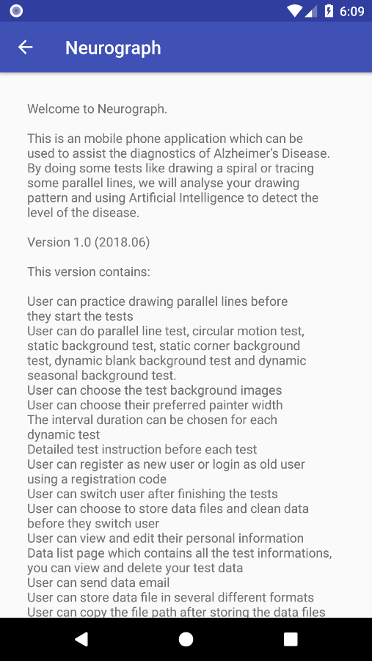View information about the app

This page contains the introduction of what’s new in this release.

# View Tutorials

You can find the tutorials of this app. They are very helpful to guide you to use this app.

You can choose any tutorial you want to view through the navigation bar on the left.

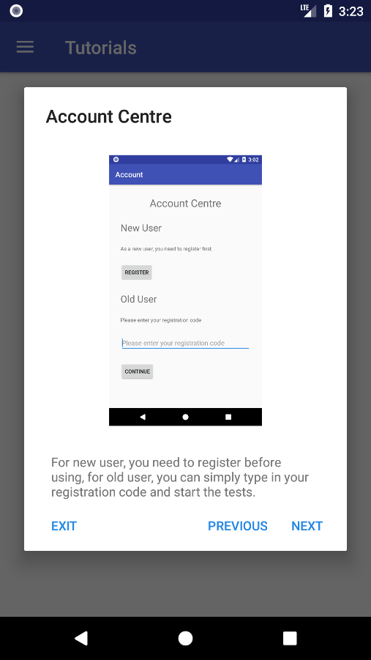For each of the tutorials, you can click “Previous” or “Next” to switch between tutorials, or you can click “Exit” to exit the tutorials.

# Click Let’s Start to log in

Please click “Let’s Start” to log in and do the tests.

# Account centre

New user needs to register before doing the tests.

Old user need to enter their registration code to continue their tests.

# Registration Page

you need to enter some information like your name, age, education level etc. This will help to make our app more accurate.

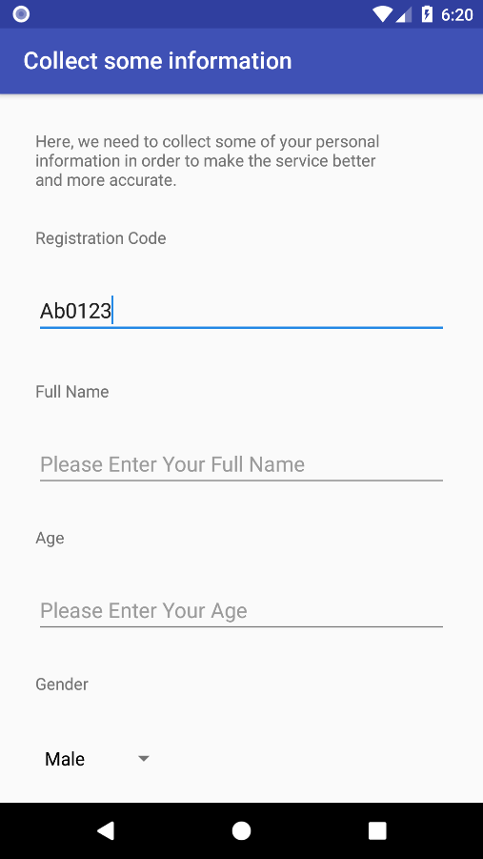Here you need to enter a registration code, this will be used if you want to come back to Neurograph and to the tests later. This registration code should contain only alphabets and numbers.

# Registration Code

The registration code cannot be empty

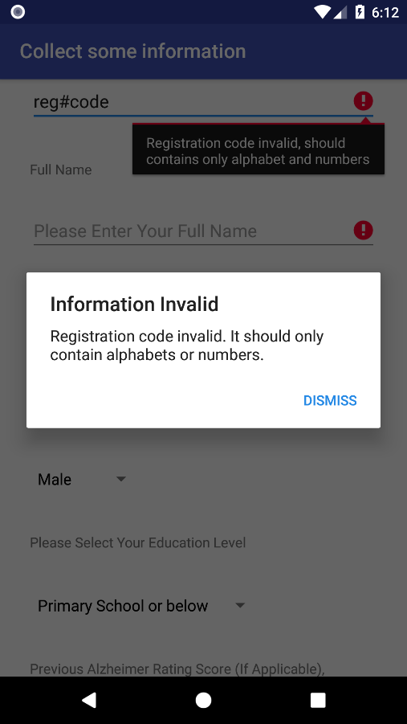The registration code can only contain number and letters (A-Z, a-z, 0-9).

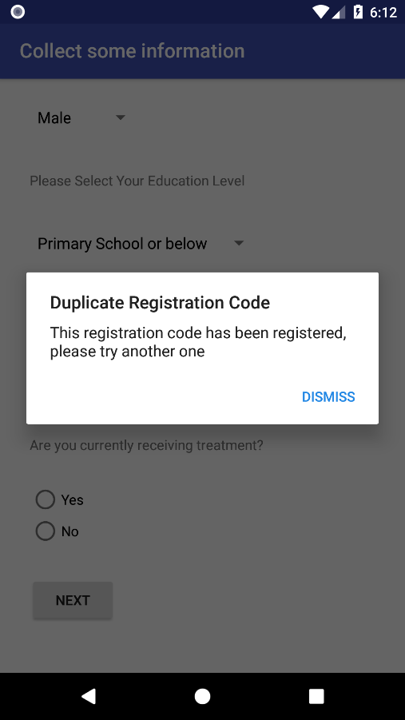The registration code also cannot duplicate, so if the registration code you entered duplicates with other patients’ registration code, you will be asked to try another one.

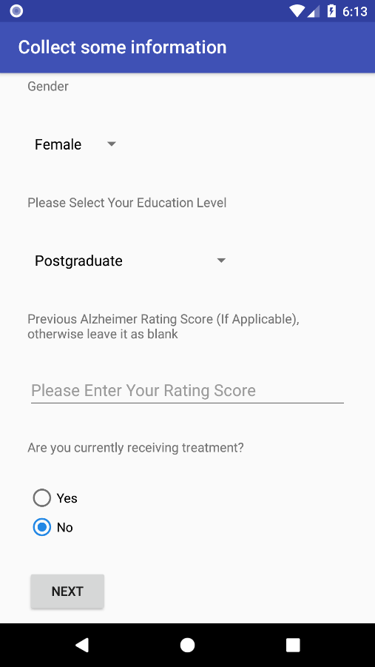Information Collection

All the information cannot be empty, except rating score. Please leave rating score blank if you don’t have previous rating score

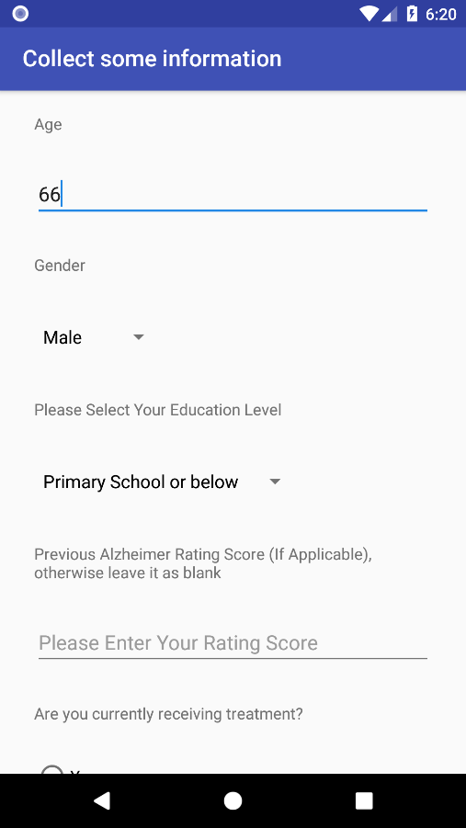The age must be a valid numerical value between 1 and 170

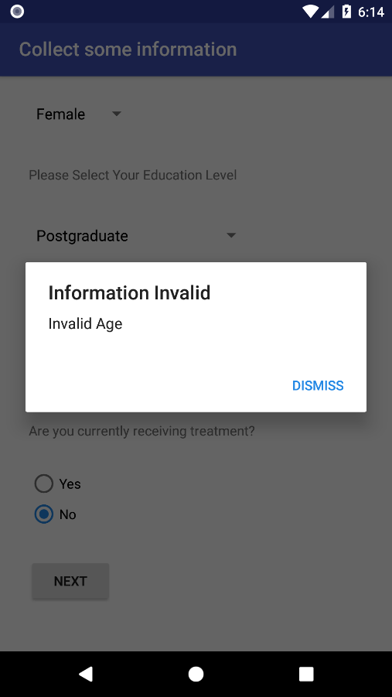If the age information you entered is invalid, you will get a prompt message reminds you the invalidity of the information.

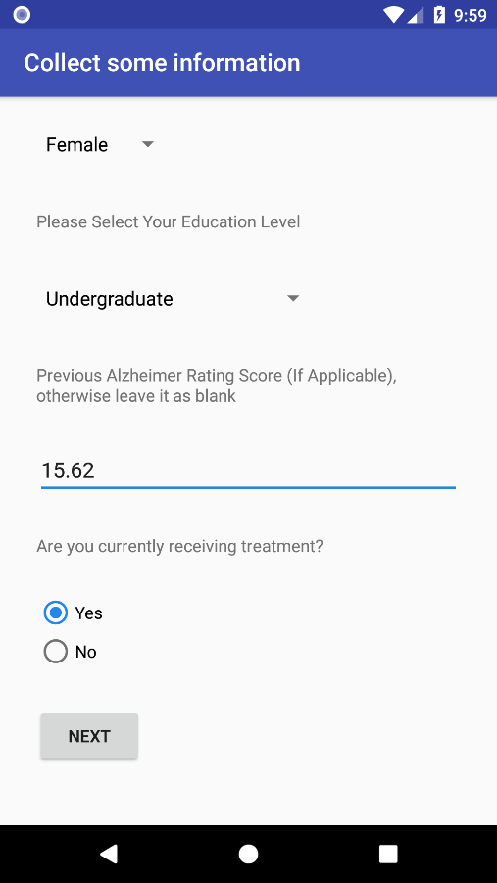If you get a rating score, it should also be a valid number

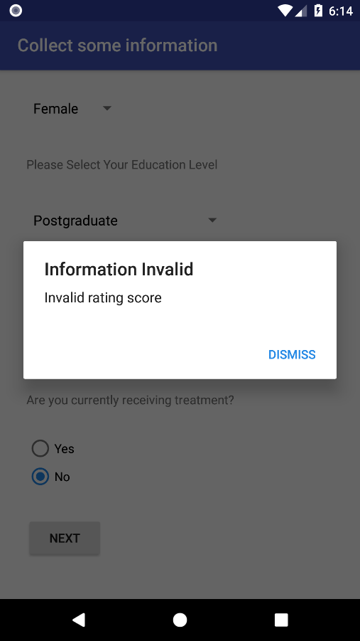Rating score should be a valid number, if the format you entered is invalid, you will get this error message.

# Test Selection

In this page you can select the tests you want to do. There are three tabs, the first tab called “Dot and Line”, which contains parallel line practice, parallel line test and circular motion test, the second tab called “Static Tests”, which contains the static full background test and static corner background test, and the third tab called “Dynamic Test”, which contains dynamic blank background test and dynamic seasonal background test. You can select multiple test to do and you can do a single test as many times as you want.

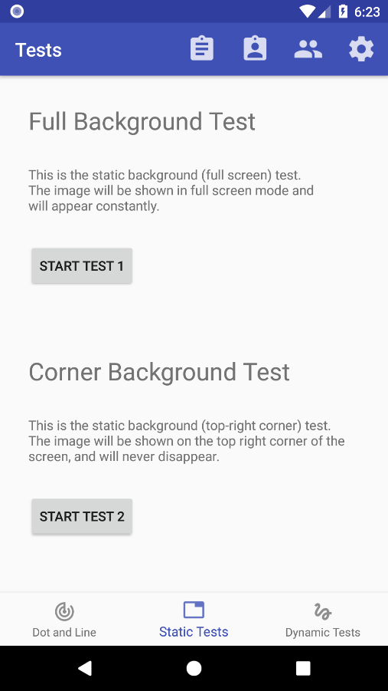

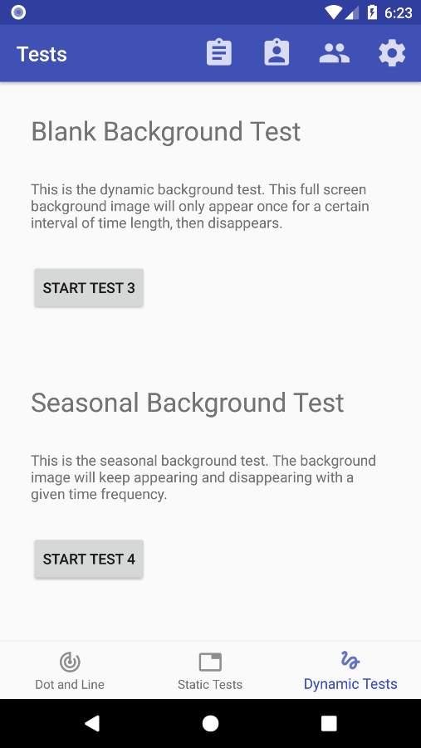

# Parallel Line Practice

# Choose painter width before starting

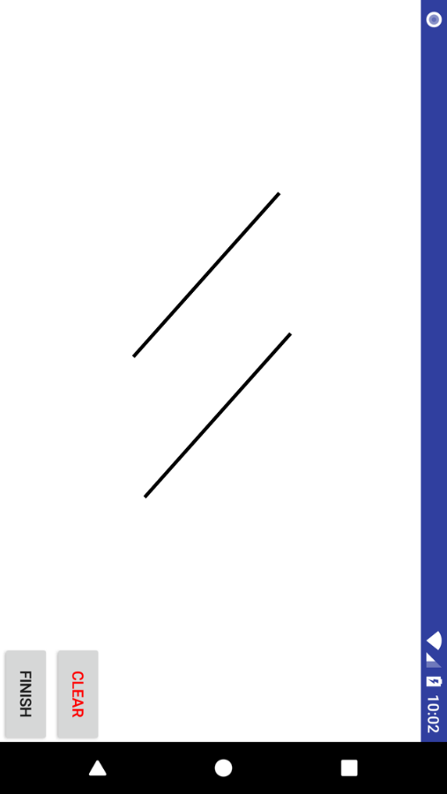This is a place where you can practice drawing on this device. In this practice, you are required to draw exactly two lines which are parallel with each other.

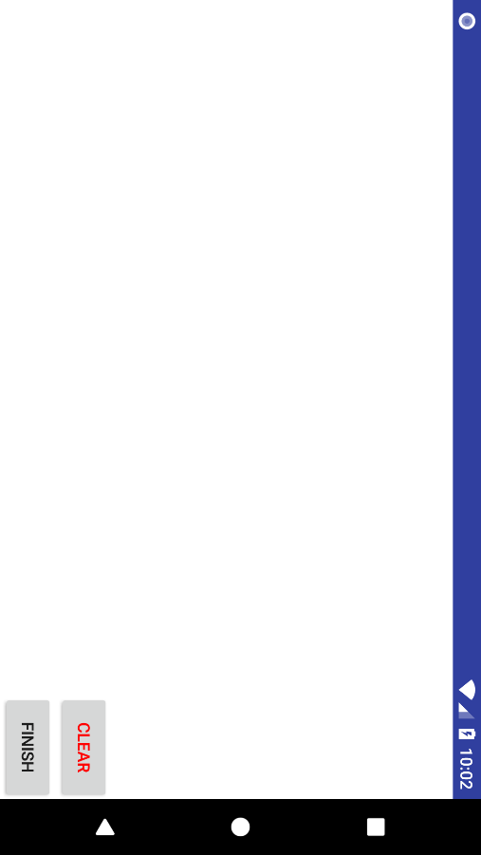Finish & Clear

Click “Finish” to finish the test, click “Clear” to clear the screen.

# C:\Users\Jiashu Wu\AppData\Local\Microsoft\Windows\INetCache\Content.Word\Screenshot_1525348926.pngCalculating Results

Please wait for a few seconds while we are processing the data. During processing please do not close the app.

# C:\Users\Jiashu Wu\AppData\Local\Microsoft\Windows\INetCache\Content.Word\Screenshot_1525349017.pngPractice Results

After finishing the practice, we will calculate whether these two lines you draw are parallel.

If there is no drawing at all or only one line, then the app will tell you “No Drawing detected”

If there are two valid lines, the app will calculate whether they are parallel or not, possible results are Perfect, Good, Acceptable, Bad or Crossing.

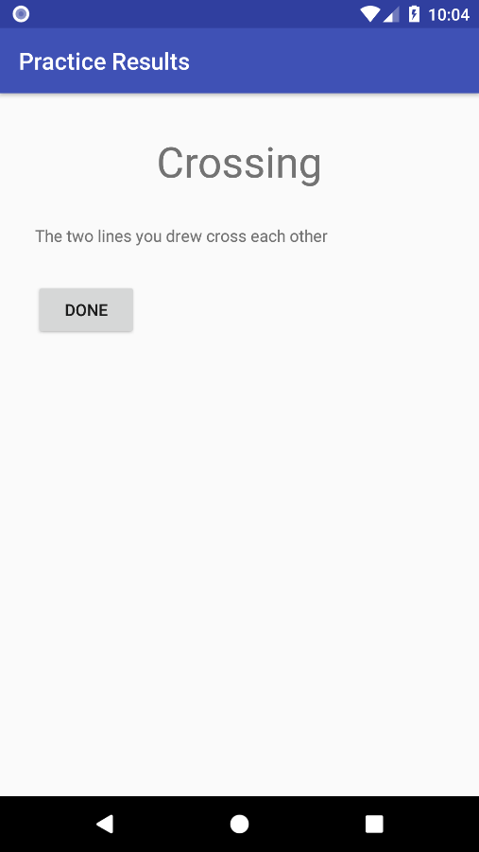

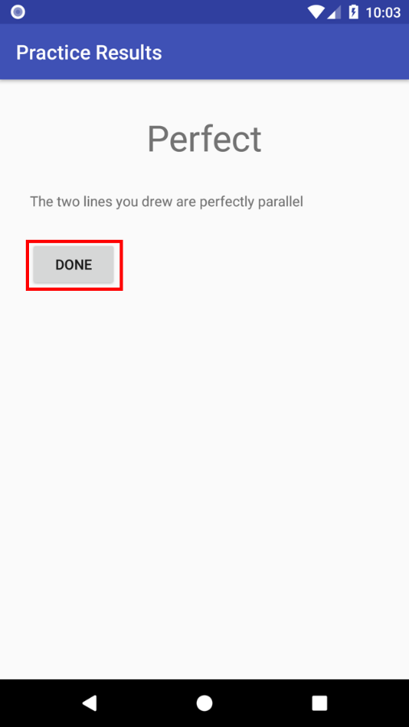Click done to exit.

# C:\Users\Jiashu Wu\AppData\Local\Microsoft\Windows\INetCache\Content.Word\Screenshot_1525349379.pngParallel Line Test

This is the Parallel Line Test. In this test you are required to follow the template image on the background, which contains three parallel lines, to draw three parallel lines on the background image.

# C:\Users\Jiashu Wu\AppData\Local\Microsoft\Windows\INetCache\Content.Word\Screenshot_1525349408.pngCircular Motion Test

This is the circular motion test. You need to draw a circle, using the dot as the centre.

# C:\Users\Jiashu Wu\AppData\Local\Microsoft\Windows\INetCache\Content.Word\Screenshot_1525349443.pngChoose the background

For Circular Motion Test, you can choose the colour of the dot. There are three colours: red, blue and black.

# C:\Users\Jiashu Wu\AppData\Local\Microsoft\Windows\INetCache\Content.Word\Screenshot_1525349611.pngStatic Full Background Test

This is the static full background test. In this test, you are required to follow the background image to draw the required shape.

# C:\Users\Jiashu Wu\AppData\Local\Microsoft\Windows\INetCache\Content.Word\Screenshot_1525349476.pngChoose test background image

In this page you need to choose the background image you want to use in this test. There are two types of image you can choose. The first one is the spiral image, and the second one is the pentagon image.

# C:\Users\Jiashu Wu\AppData\Local\Microsoft\Windows\INetCache\Content.Word\Screenshot_1525349703.pngChoose painter width

You also need to choose the painter width.

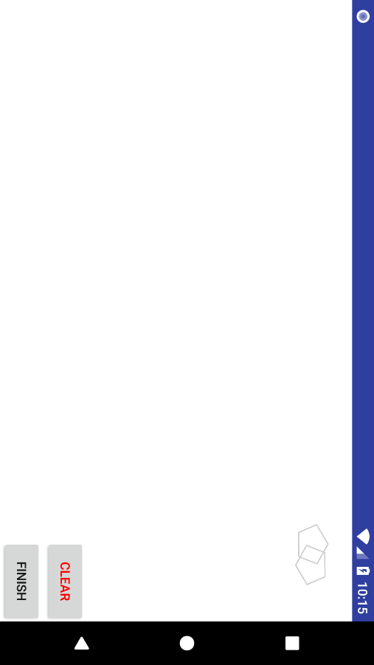

Static Corner Background Test

This is the static corner background test. In this test the background image is located on the top-right corner of the screen. You are required to draw the required shape in that image.

# Dynamic Blank Background Test

This is the dynamic blank background test. In this test, the background image will first appear for a specific period of time, then disappear. You need to remember the background pattern and draw the shape on a blank screen after the background image disappears.

# C:\Users\Jiashu Wu\AppData\Local\Microsoft\Windows\INetCache\Content.Word\Screenshot_1525408508.pngChoose Time Interval

You need to choose how long you want the background image to show at the beginning of the test.

# Dynamic Seasonal Background Test

This is the dynamic seasonal background test. In this test the background image will keep appearing and disappearing, with certain time interval specified. You are required to follow the background image to draw the required shape.

# C:\Users\Jiashu Wu\AppData\Local\Microsoft\Windows\INetCache\Content.Word\Screenshot_1525408508.pngChoose Time Interval.

You need to choose the time interval for the background image to keep appearing and disappearing.

# Test Selection Page toolbar

You can click here to access the data list.

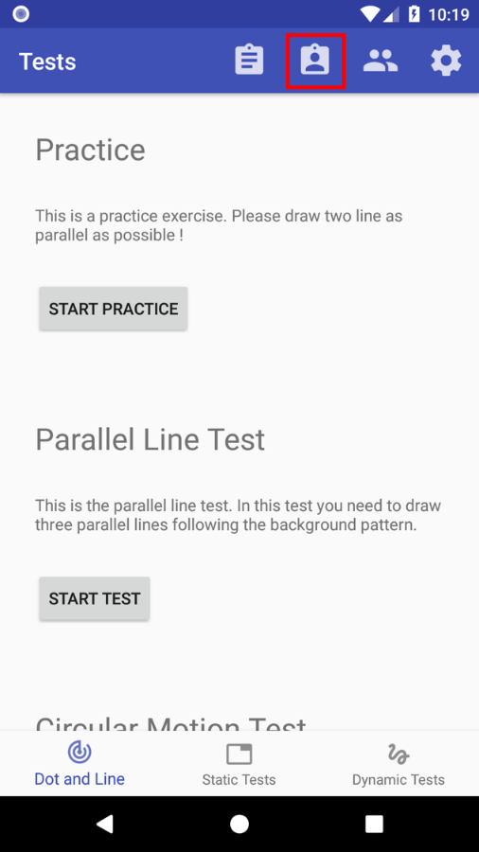You can click here to view or edit your personal information

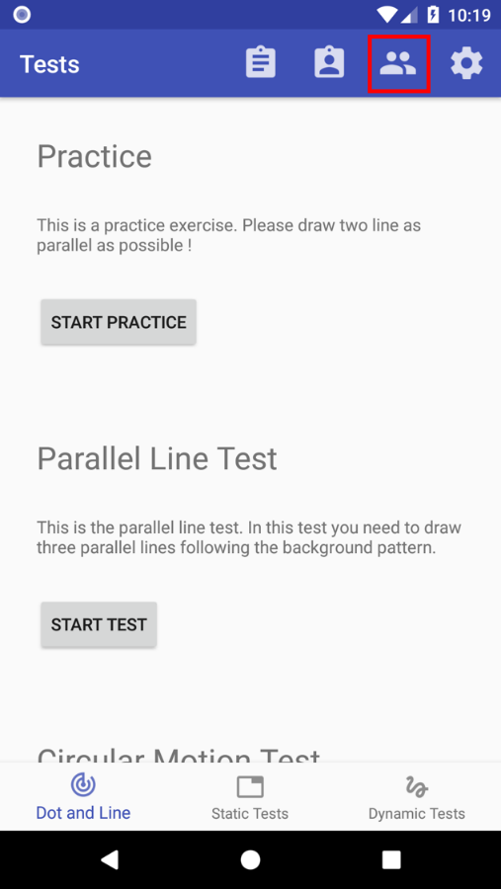You can click here to switch user

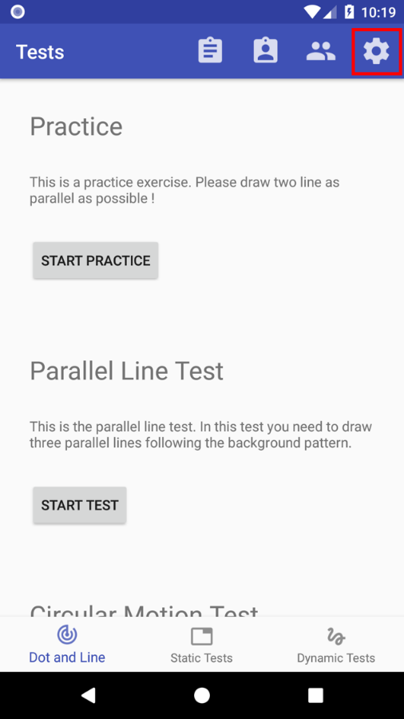You can click here to change the setting of language and font size.

# C:\Users\Jiashu Wu\AppData\Local\Microsoft\Windows\INetCache\Content.Word\Screenshot_1525409550.pngData List

Here you can see all test of all the users.

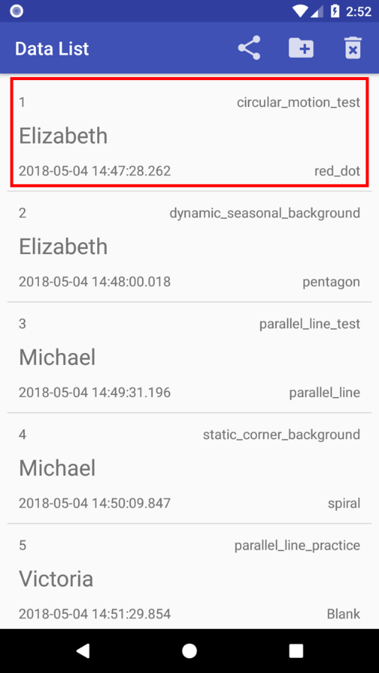Each tab shows the test ID, the testee’s name, the test date and time, test type and image type.

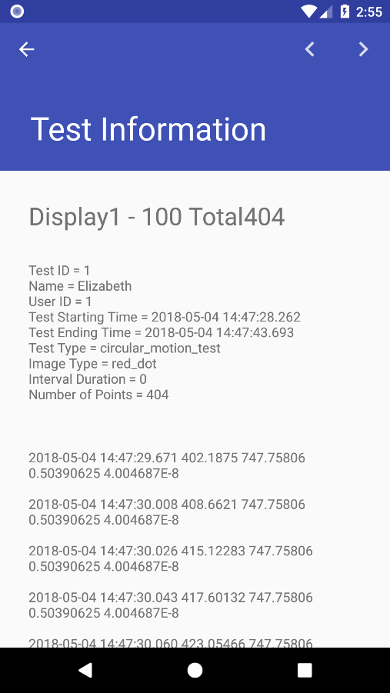Click the tab to see the details of this test.

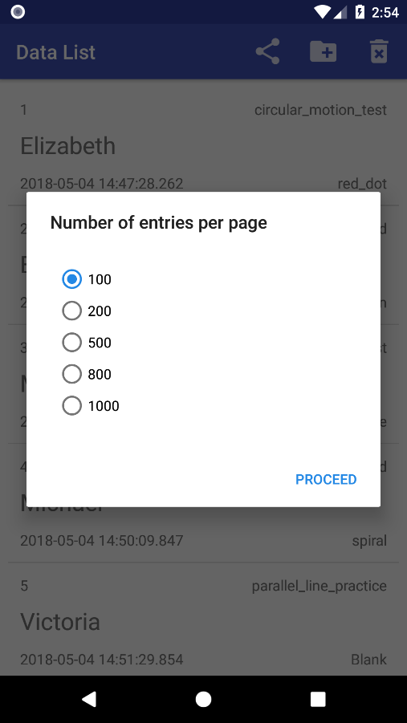You need to choose how many entries you want to show on each page. Since in each single test there can have many data points.

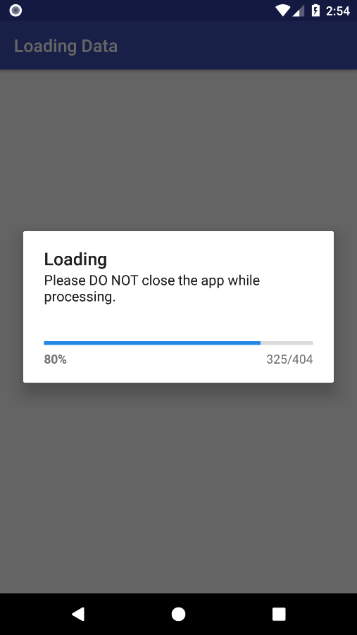Loading

During the loading process please do not close the app.

# C:\Users\Jiashu Wu\AppData\Local\Microsoft\Windows\INetCache\Content.Word\Screenshot_1525409757.pngTest Information

Here you can see all the information about this test, including the test ID, testee ID, testee name, test starting time, test ending time, test type, image type, interval duration, number of points collected, and the x, y coordinates, pressure and touch point size of every single point collected in this test.

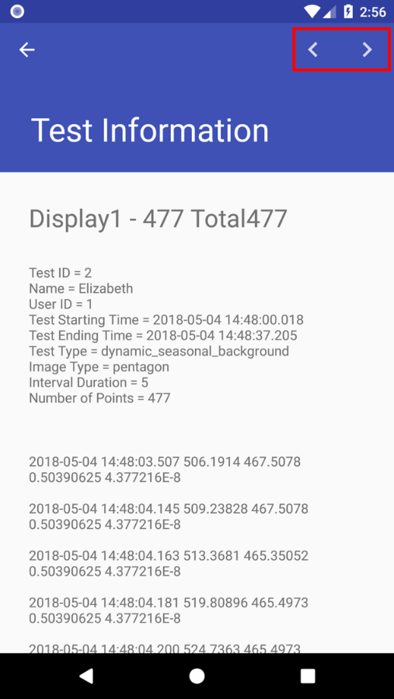Click here to go to the previous / next page.

# C:\Users\Jiashu Wu\AppData\Local\Microsoft\Windows\INetCache\Content.Word\Screenshot_1525350437.pngLong click to delete a test.

You can delete a test by long clicking it in the data list.

# C:\Users\Jiashu Wu\AppData\Local\Microsoft\Windows\INetCache\Content.Word\Screenshot_1525413988.pngSending Data File Email

There must have some test data to be sent via email. If there is no test data, you can’t send an email.

# C:\Users\Jiashu Wu\AppData\Local\Microsoft\Windows\INetCache\Content.Word\Screenshot_1525350559.pngEmail Recipient and Email Subject

You can send all the test data via email. In this page you need to enter the recipient email address, this email address cannot be empty, and it should also be a valid email address, which means it should contain “.” And “@”. You also need to enter the subject of the email. This cannot be empty as well.

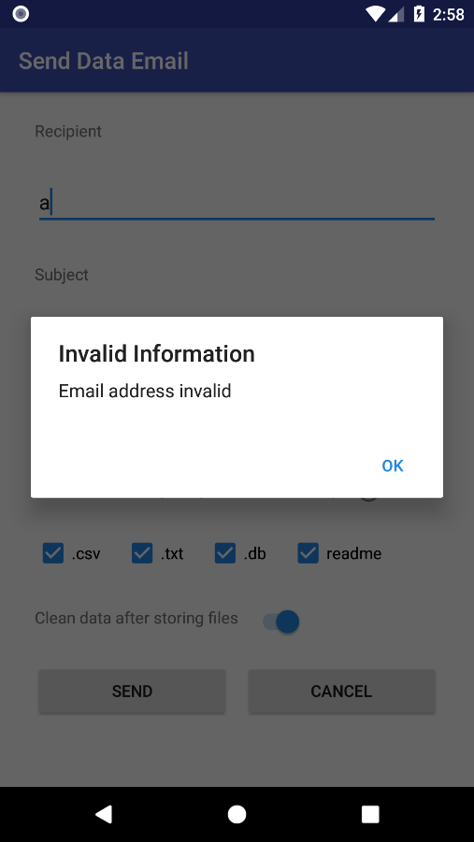The email address cannot be invalid.

# C:\Users\Jiashu Wu\AppData\Local\Microsoft\Windows\INetCache\Content.Word\Screenshot_1525350653.pngAutomatically remember the email address used previously

The app will automatically remember the email address used previously

# Email Content

You can choose to show the data details as content of your email.

# Email Attachment Data Files

You can choose which type of file you want to send. You can choose all of them, but you need to choose at least one.

# Data Files Help

Click here to see what these file types mean.

# C:\Users\Jiashu Wu\AppData\Local\Microsoft\Windows\INetCache\Content.Word\Screenshot_1525350857.pngHelp Message

.txt means text file

.csv means comma separated value file

.db means database file

Readme contains the instruction and explanation of the data files.

# Clean data after sending files

You can choose to clean all the test data on this device after sending the data email.

# C:\Users\Jiashu Wu\AppData\Local\Microsoft\Windows\INetCache\Content.Word\Screenshot_1525350527.pngPermission

For a successfully sending, you need to grant the permission to Neurograph. This permission granting message will only be shown once. You can go to your device’s setting to change the permissions.

# C:\Users\Jiashu Wu\AppData\Local\Microsoft\Windows\INetCache\Content.Word\Screenshot_1525413697.pngNetwork Connection

For a successfully sending, your device needs to connect to a stable network, either WiFi or mobile network. The app will automatically detect network state, if there is no network connection, you cannot send an email.

# C:\Users\Jiashu Wu\AppData\Local\Microsoft\Windows\INetCache\Content.Word\Screenshot_1525351075.pngCancel sending

You can click “Cancel” to cancel sending this email.

# Send it

Click “Send” to send it. During the sending process please do not close the app.

# C:\Users\Jiashu Wu\AppData\Local\Microsoft\Windows\INetCache\Content.Word\Screenshot_1525409991.pngSending Progress

During the sending progress, please do not close the app, otherwise the data email cannot be sent successfully.

# C:\Users\Jiashu Wu\AppData\Local\Microsoft\Windows\INetCache\Content.Word\Screenshot_1525410045.pngSuccessfully Sent

The email which contains the data files has been sent successfully, and the data files have also been stored on your device.

# Notification

When the sending process finished, you will receive a notification.

# C:\Users\Jiashu Wu\AppData\Local\Microsoft\Windows\INetCache\Content.Word\Screenshot_1525410061.pngCopy File Path

You can copy the file path of the data file to clipboard.

# C:\Users\Jiashu Wu\AppData\Local\Microsoft\Windows\INetCache\Content.Word\Screenshot_1525410191.pngStore Data File

You can store the data file without sending it through email. You also need to choose the file type you want to store, you can choose all of them and you need to choose at least one of it. After storing data file, you can choose to clean all the test data. Click “Help” to see what these file types mean.

# C:\Users\Jiashu Wu\AppData\Local\Microsoft\Windows\INetCache\Content.Word\Screenshot_1525410289.pngGenerating Progress

During the generation process please do not close the app.

# C:\Users\Jiashu Wu\AppData\Local\Microsoft\Windows\INetCache\Content.Word\Screenshot_1525410268.pngCopy File Path

You can copy file path to the clipboard.

# Delete Data

You can click here to delete data.

# C:\Users\Jiashu Wu\AppData\Local\Microsoft\Windows\INetCache\Content.Word\Screenshot_1525350367.pngThree delete options.

There are three deletion options.

You can choose to delete all the test data only, delete all the test data before a specific date, or delete all the user and test data, and this will restart the app.

# C:\Users\Jiashu Wu\AppData\Local\Microsoft\Windows\INetCache\Content.Word\Screenshot_1525350393.pngDelete test data before specific date

You can delete test data before a specific date.

# View and Edit Personal Information

You can click here to view or edit your personal information.

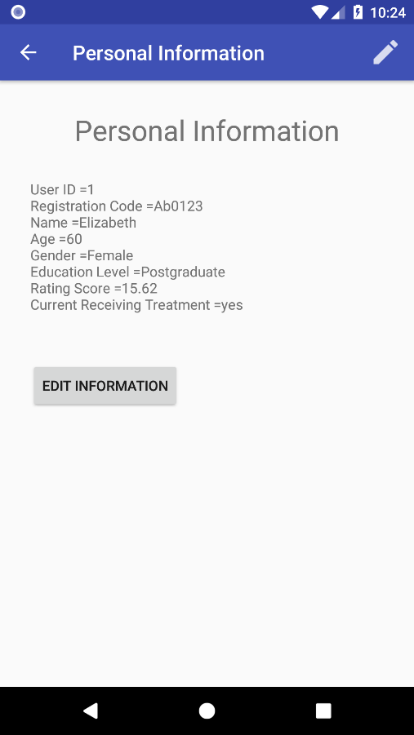

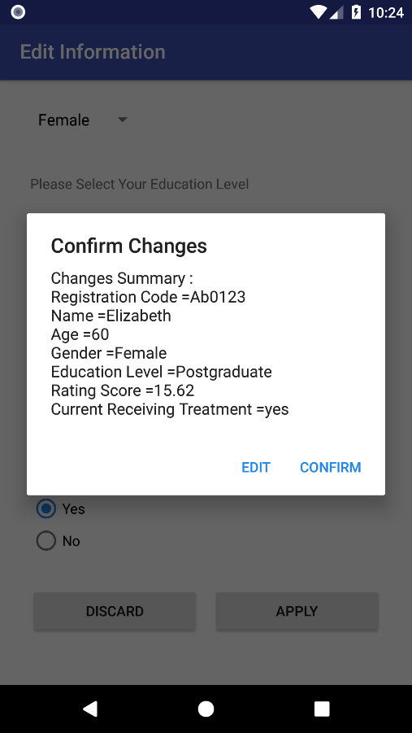

# Switch User

You can click here to switch user.

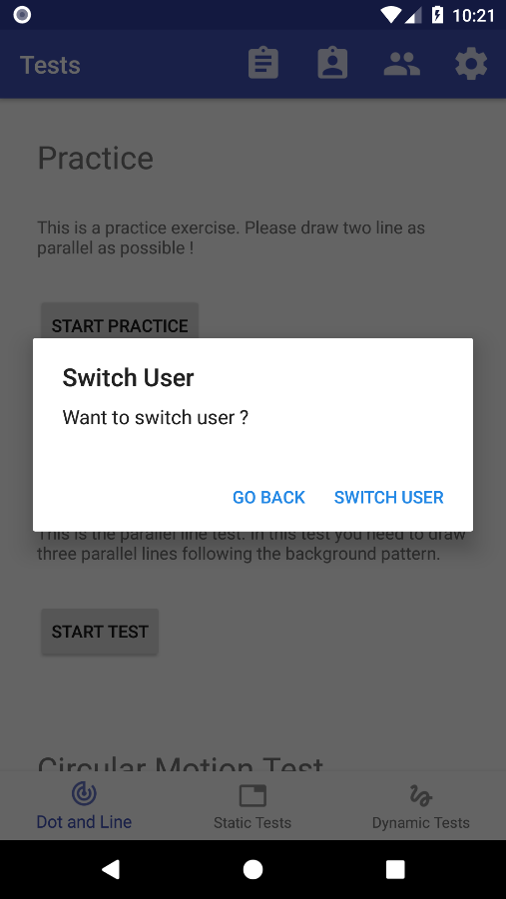

# C:\Users\Jiashu Wu\AppData\Local\Microsoft\Windows\INetCache\Content.Word\Screenshot_1525350136.pngStore Files before switching user

You can choose to send data email, store data file before switching user. Or you can also choose not to store at this point.